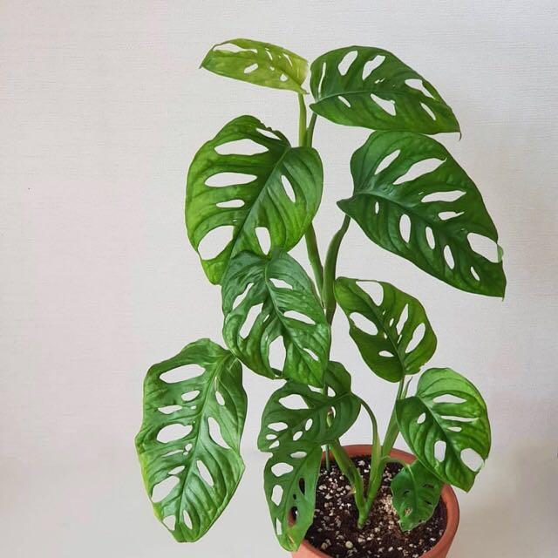
  - Take and Make: Plant Propagation
Monstera Adansonii (Swiss Cheese Plant)
Refer to Jenna’s video on Facebook
for further instructions: https://youtu.be/mQCX9s_PLgY

Kit Contains:
- Cuttings of Monstera Adansonii (Swiss Cheese Plant) node
- To-go plastic container
- Sphagnum moss
- 2” pot for transplant
- Planting medium
Remember that the node is the gardener’s term for a thickened, nub-like area of the stem. When your plant branches or puts out a new leaf, the new growth comes from the node. Your cutting will have at least one node (or bump) where the new roots will grow from.
To propagate:
- Put moss in container, add water until just wet.
- Squeeze out excess water. Moss should be damp, not wet. Remove about 1/3 of moss for later
- Place cutting on the moss, then cover the cutting with the rest of the damp moss.
- Close container.
- Place in medium (not direct light) and wait for a few weeks.
- Check every few days. Condensation should appear on the top/sides of container. If moss seems too wet, then open container for a few hours. If the moss is too wet, then the node will rot. If moss seems too dry, then spray some water on it.
- Wait until your node has 1” of roots before transplanting to a well-draining soil

Plant care: Swiss cheese plants do fine in bright or medium indirect light and prefer soil that doesn’t get watered until the top half inch is dry to the touch. Don’t let it dry out completely.

If you have questions, please reach out to Jenna or Julie:
hartej@evergreenparklibrary.org, keatyj@evergreenparklibrary.org

